Hands-On Assignment 2: Constructing an AI QR Code
Generator with Python

Xhon Pelushi
University of the Cumberlands
MSCS-633-M20: Advance Artificial Intelligence
Hands-On Assignment 2
Dr. Vouama
September 18, 2026

Introduction
The QR code, short for quick-response code, was invented in 1994 by the Japanese company Denso Wave to track automotive parts more quickly than the one-dimensional barcodes of the time allowed (Denso Wave Incorporated, n.d.). Where a conventional barcode encodes data along a single axis, a QR code uses both, writing its payload into a square grid of light and dark modules that a camera can read from any orientation. The symbology is now standardized as ISO/IEC 18004 (International Organization for Standardization, 2015), which is why a code produced by one program can be read by an unrelated scanner on an arbitrary phone.
This assignment asked for an application that generates a QR code when a URL address is supplied, with the Biox Systems web address as the target. The program I wrote, qr_generator.py, reads a URL either from the command line or from an interactive prompt, checks that it is a usable web address, encodes it, and writes the result as a PNG image. This report describes the environment and manifest, the design of the program, the coding practices it follows, and the output it produces, and it gives the URL of the GitHub repository holding the source code.
The exercise is a fitting opening for a course on artificial intelligence because a QR code exists precisely to be read by a machine rather than by a person. Generating one is the encoding half of a machine-perception problem whose decoding half — locating a square symbol in a noisy photograph, correcting for perspective, and recovering the payload from partially damaged data — is solved today by the computer-vision routines built into every smartphone camera.
Development Environment and Manifest
The application was developed and tested on Ubuntu with Python 3.12.3. Because recent Ubuntu releases mark the system interpreter as externally managed and refuse package installation into it, the dependencies were installed into a project-local virtual environment rather than system-wide. This also keeps the assignment reproducible: anyone who clones the repository gets exactly the versions recorded in the manifest and nothing else.
The manifest file is requirements.txt, the conventional dependency declaration for a Python project. It pins a single direct dependency:
# Manifest for the AI QR Code Generator
# Install with: pip install -r requirements.txt

qrcode[pil]==8.2
The qrcode package is the library named in the assignment instructions; it implements the encoding, masking and error-correction steps of the QR specification (Lincoln Loop, n.d.). The [pil] extra pulls in Pillow, which qrcode uses to rasterize the module grid into an image file. Pinning the version with == rather than accepting whatever is current means the program will keep behaving as it does in the screenshots below. Installing from the manifest resolved to qrcode 8.2 and Pillow 12.3.0, as Figure 1 shows.
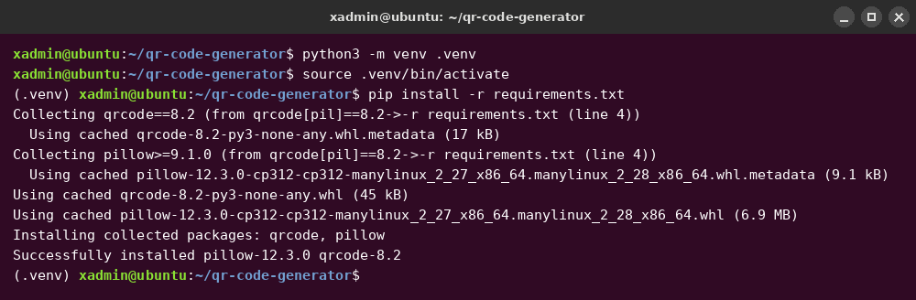
Figure 1. Creating the virtual environment and installing the dependencies from the manifest.

Program Design
The program is organized as a set of small functions, each responsible for one step of the work, with a main function that sequences them. Separating the steps this way keeps every piece independently understandable and testable, and it means the encoding logic can be reused by another program without dragging the command-line interface along with it.
normalize_url cleans up what the user typed. People habitually write "www.bioxsystems.com" instead of the full "https://www.bioxsystems.com/", and while a QR code holding the short form is still a valid QR code, many scanners treat a string without a scheme as plain text rather than as a link to open. The function therefore prefixes https:// whenever the input does not already begin with a scheme, which it detects with a regular expression rather than by searching for "://" anywhere in the string.
validate_url then decides whether the result is worth encoding. Using urllib.parse.urlparse from the standard library, it rejects anything whose scheme is not http or https, anything with no host component at all, and any host without a dot in it. A QR code will happily encode nonsense, so the check exists to catch the user's mistake at the point where it can still be corrected, rather than producing an image that silently fails to work when someone scans it.
make_qr_image performs the encoding. It builds a qrcode.QRCode object with version set to None, which lets the library choose the smallest symbol version — that is, the smallest grid — that the data fits into, and with error correction set to level H. Level H is the highest of the four levels defined by the standard and reserves enough Reed-Solomon redundancy to restore roughly thirty percent of the codewords, which suits a code that will be printed, screenshotted or scanned at an angle. Each module is drawn ten pixels wide, and the symbol is surrounded by a border four modules deep: this is the quiet zone the specification requires, and without it a scanner cannot reliably find the edges of the symbol against the surrounding page.
The remaining functions handle input and output. default_filename derives a safe file name from the host part of the URL, so https://www.bioxsystems.com/ becomes www_bioxsystems_com_qr.png, and parse_arguments defines the command-line interface with argparse (Python Software Foundation, n.d.): an optional positional URL and an optional -o flag naming the output file. main ties these together, falling back to an interactive prompt when no URL was given on the command line and accepting the Biox Systems address as the default if the user simply presses Enter.
Coding Best Practices
The assignment asked that the code follow best practices and carry comments, so several specific habits were applied throughout. Every function carries a docstring stating what it returns or raises, and the module itself opens with a docstring explaining what a QR code is and how the program is invoked. Comments inside the functions are reserved for explaining why a decision was made — why the quiet zone is four modules, why a scheme is added, why an invalid URL exits with a non-zero status — rather than restating what the next line plainly does.
The tunable values are named constants at the top of the file rather than numbers buried in the middle of a function, so the module size, quiet-zone width, colors, default URL and accepted schemes can all be changed in one obvious place. The advice that a program should avoid scattering magic values and should keep its configuration together is not specific to any one language; it appears in the same form in the W3C's best-practice guidance (W3C, n.d.), and it applies as directly to Python as to JavaScript.
Errors are handled deliberately. A bad URL is a user mistake rather than a program fault, so validate_url raises a ValueError with a message that names the actual problem, main catches it, prints it to standard error, and returns exit status 1 so that a calling script can detect the failure. A failure to write the PNG is caught separately as an OSError. Neither case produces a stack trace, which would tell the user nothing useful. Finally, the module guards its entry point with the standard if __name__ == "__main__" check and passes main's return value to sys.exit, so the file can be imported by other code — or by a test — without running the interface, while still behaving correctly as a script. Naming, spacing and line length follow PEP 8 (Van Rossum et al., 2001).
Application Output
Figure 2 shows the primary run. The program is started with no arguments, prints its banner, and prompts for a URL; pressing Enter accepts the default Biox Systems address. It reports the URL it encoded, the dimensions of the image and the file it wrote. The 410 × 410 pixel size follows from the content: at error-correction level H the URL fits into a version 4 symbol, which is 33 modules square, and 33 modules plus the four-module quiet zone on each side, at ten pixels per module, gives 410 pixels.
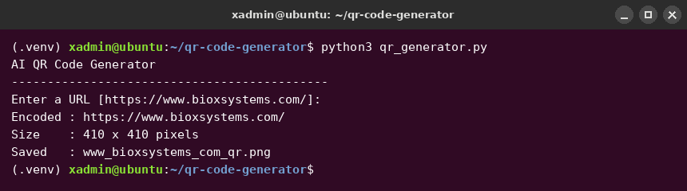
Figure 2. Interactive run encoding the Biox Systems URL.
Figure 3 is the QR code that run produced. Scanning it with any phone camera opens https://www.bioxsystems.com/.
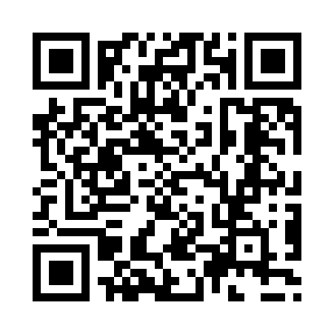
Figure 3. The generated QR code for https://www.bioxsystems.com/ (www_bioxsystems_com_qr.png).
Figure 4 demonstrates the other two paths through the program. The first command passes a URL as an argument instead of typing it at the prompt, producing the second QR code shown in Figure 5. The second command supplies an unusable input, and the validation described earlier rejects it with a specific message; echo $? confirms that the program exited with status 1 rather than pretending to succeed.
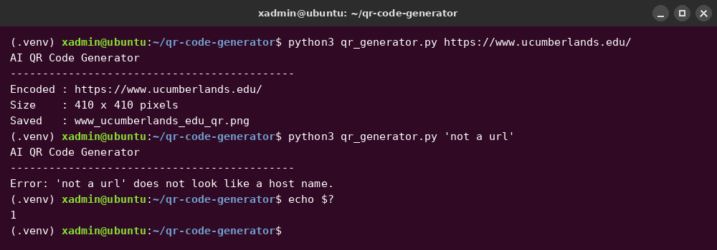
Figure 4. A URL supplied as a command-line argument, and the error path for an invalid address.
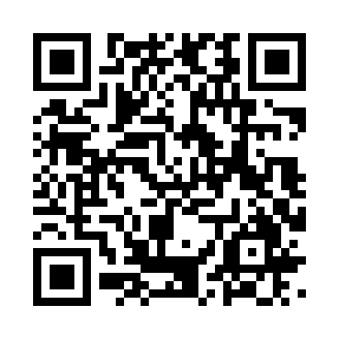
Figure 5. The generated QR code for https://www.ucumberlands.edu/ (www_ucumberlands_edu_qr.png).
Figure 6 shows the help text argparse generates from the argument definitions, which is what a user sees when they run the program with --help.
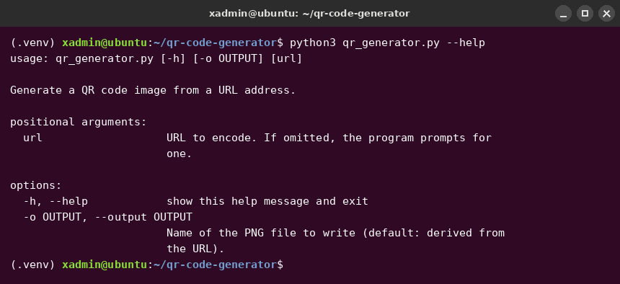
Figure 6. The command-line help.
Verification
Producing an image that looks like a QR code is not the same as producing one that decodes, so both outputs were read back with an independent decoder. OpenCV's QRCodeDetector (OpenCV, n.d.), which shares no code with the generating library, recovered https://www.bioxsystems.com/ from the first image and https://www.ucumberlands.edu/ from the second — in both cases the exact string that was encoded, with no substitutions and nothing truncated. The images in this report are therefore scannable, not merely decorative.
Source Code Repository
The source code, the manifest and the output images are published in the GitHub repository for this course:
https://github.com/xhon-pelushi/MSCS-633-Advance-Artificial-Intelligence
The assignment lives in the Hands-On-Assignment-2-QR-Code-Generator folder, which contains qr_generator.py, requirements.txt, this report, the two generated QR codes, the screenshots reproduced above, and a README giving the setup and run instructions.
Conclusion
The finished application does what the assignment asked: given a URL address, it produces a QR code image that a phone camera opens as that address. The work that made it more than a three-line script was the part around the encoding — normalizing what the user typed, refusing input that would produce a useless code, choosing an error-correction level suited to how the image will actually be used, and reporting failures in a way that tells the user what went wrong. Reading the results back with an unrelated decoder confirmed that the codes carry the intended payload, which closes the loop between the encoding side of the problem and the machine-perception side that will occupy much of this course.

References
Denso Wave Incorporated. (n.d.). History of QR Code. https://www.denso-wave.com/en/technology/vol1.html
International Organization for Standardization. (2015). Information technology — Automatic identification and data capture techniques — QR Code bar code symbology specification (ISO/IEC 18004:2015).
Lincoln Loop. (n.d.). qrcode: QR Code image generator (Version 8.2) [Computer software]. Python Package Index. https://pypi.org/project/qrcode/
OpenCV. (n.d.). cv::QRCodeDetector class reference. https://docs.opencv.org/4.x/de/dc3/classcv_1_1QRCodeDetector.html
Python Software Foundation. (n.d.). argparse — Parser for command-line options, arguments and subcommands. https://docs.python.org/3/library/argparse.html
Van Rossum, G., Warsaw, B., & Coghlan, N. (2001). PEP 8 — Style guide for Python code. Python Software Foundation. https://peps.python.org/pep-0008/
W3C. (n.d.). JavaScript best practices. https://www.w3.org/wiki/JavaScript_best_practices

